Slide 16/19
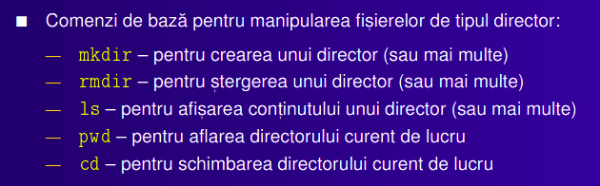

mkdir – MaKe DIRectory
rmdir – ReMove DIRectory
ls – LiSt content of directory
pwd – Print Working Directory
cd – Change Directory

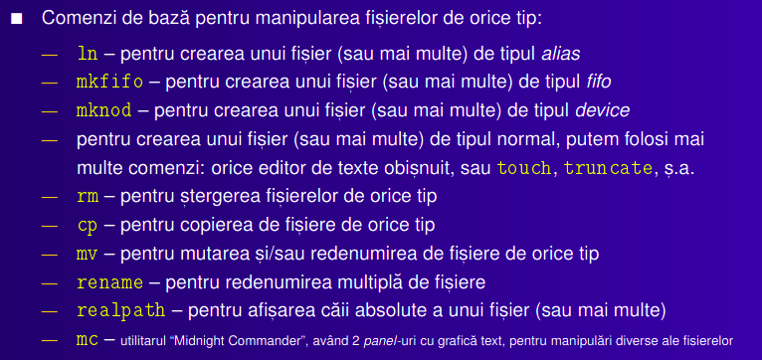
slide 17/19

ln – make LiNk file
mkfifo – MaKe FIFO file
mknod – MaKe NODe file
touch, truncate – make text file
rm – ReMove file
cp – CoPy file
mv – MoVe file, or rename file
rename – well, RENAME file
realpath – print REAL PATH of a file
mc – Midnight Commander or Manipulate Current file

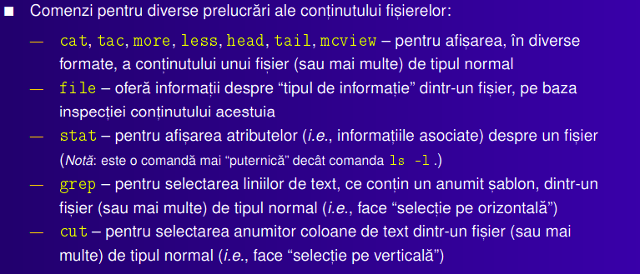
slide 18/19

cat, tac – conCATenate and print file in order/ reverse order
more, less – prints as many lines as they can fit on the screen & you need to press ENTER to see more of the file
head, tail – prints the first/ last parts of the specified file
mcview – connected to Midnight Commander
file – determine the type of the file
stat (ls -l) – print atributes of a file
grep – print lines with matching pattern
cut – print columns with matching pattern

